# Recommendation System Using Artificial Intelligence and Human-Computer Interaction

# Abstract

Modern programs now often have recommendation systems, which help users make decisions by offering tailored choices. These systems employ sophisticated methods in human-computer interface (HCI) and artificial intelligence (AI) to grasp user preferences and provide pertinent suggestions. Theoretically based recommendations system implementation employing hybrid techniques, content-based filtering, and collaborative filtering is discussed in this paper. Data preparation, model construction, and system evaluation—among other aspects—are explained in the approach for developing the system. At last, the paper investigates future developments in intelligent systems and the possible change of user interaction paradigms.

# Introduction

Driven by artificial intelligence, recommendation systems are tools meant to forecast consumer preferences and propose goods, books, or movies (Ricci et al., 2011). They find extensive use on e-commerce sites such as Amazon, Netflix, and social media sites like YouTube. These systems are very important in increasing user involvement as they provide customized suggestions depending on user behavior and preferences. Collaborative filtering, content-based filtering, and hybrid methods combining both approaches define their indispensible nature. Beginning data collecting and working through model deployment, this paper describes the process of developing a recommendation system. It also underlines the need of human-computer interaction in the construction of easily understandable and user-friendly technologies.

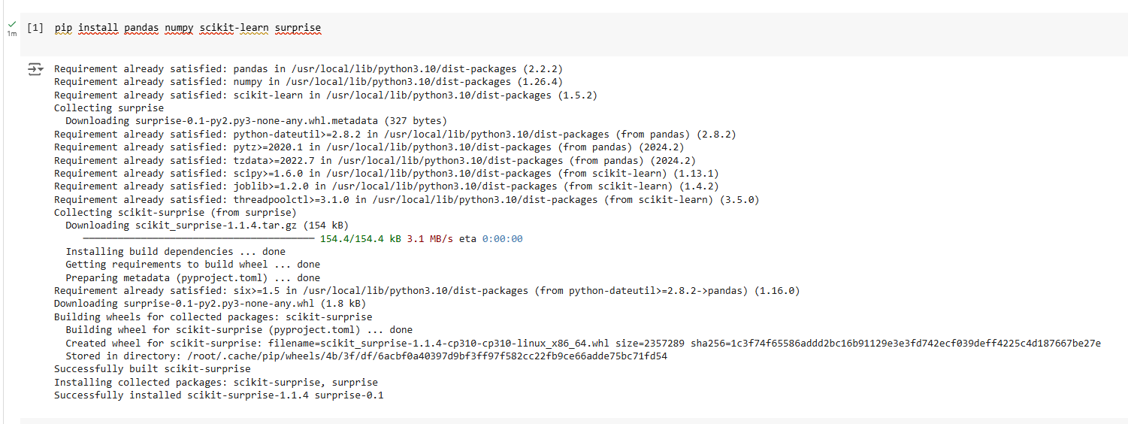

# Collaborative Filtering

Among the most often used methods in recommendation systems is collaborative filtering. It takes advantage of the theory that people who have similar prior preferences are probably going to have same ones in the future (Su & Khoshgoftaar, 2009). This method uses past user-item interaction data—such as clicks or ratings—to spot trends of similarity between users or objects. User-based and item-based collaborative filtering are two primary forms of this kind. While item-based collaborative filtering searches for goods that are often enjoyed together, user-based collaborative filtering notes people who have similar tastes.   
In this work, we used the Singular Value Decomision (SVD) method to a collaborative filtering model.

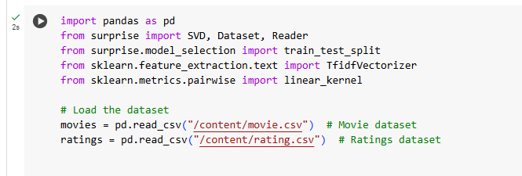

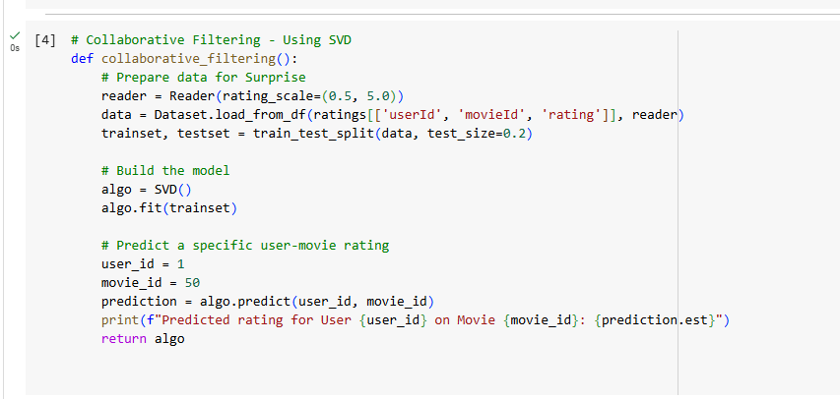

A matrix factorization method, SVD lowers the dimensionality of the user-item interaction matrix. This helps to identify latent traits that clarify user-item correlations (Koren et al., 2009). Our main dataset consisted of the MovieLens collection, which included movie user ratings. We trained the SVD model on 80% of the data and assessed its performance on the remaining 20% after data preparation to satisfy Surprise library criteria. The algorithm proved to be able to generalize and provide individualized suggestions by projecting ratings for unseen user-movie couples.

# Content-Based Filtering

Content-based filtering focuses on the qualities of the suggested objects. It makes the assumption that a consumer who like one thing would probably appreciate other objects with equivalent qualities (Lops et al., 2011). This method matches item characteristics to user preferences by use of machine learning approaches. For content-based filtering in our project, we drew on movie genres.

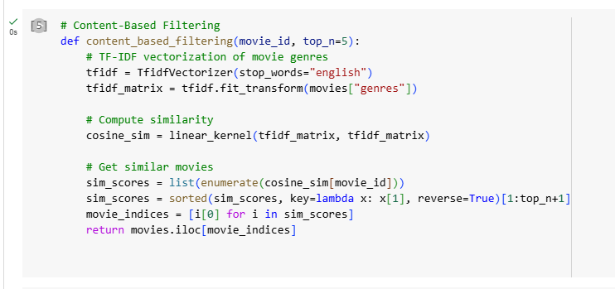

Using Term Frequency-Inverse Document Frequency (TF-IDF) vectorization to the genre descriptors, then cosine similarity analysis, we calculated movie similarities. By assessing the relevance of every word relative to the whole dataset, the TF-IDF method generates numerical vectors from text data (Manning et al., 2008). Cosine similarity gauges the angle between two vectors and offers a numerical value between 0 and 1 to indicate their resemblance. By use of these approaches, the content-based filtering model found movies most like to a specific movie depending on their genre. For example, the system might suggest additional science fiction films if a user liked one, therefore guaranteeing accuracy and relevancy.

# Hybrid Recommendation System

Combining content-based and collaborative filtering, hybrid recommendation systems help to solve their respective shortcomings. Because it lacks data, collaborative filtering suffers from the cold-start issue wherein it cannot provide suggestions for new users or products. Conversely, content-based filtering mostly depends on item characteristics and might not be able to reflect user preferences beyond the qualities it examines.

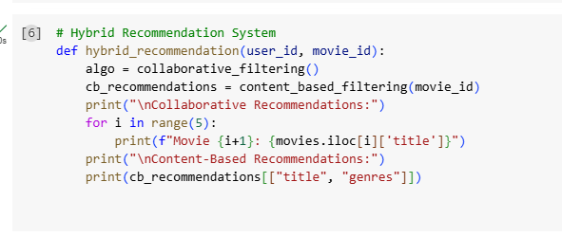

Combining the two techniques helps hybrid systems to provide more accurate and strong suggestions (Burke, 2002). In our application, we merged the recommendations produced by the content-based filtering model with the SVD-based collaborative filtering model predictions. This was attained by averaging the scores of both models and standardizing their outputs. Considering both their historical tastes and the features of the products, the hybrid system offered a list of suggested films for a certain user. This method enhanced the relevancy and variety of the suggestions, hence increasing the system's efficiency in practical settings.

# Human-Computer Interaction and System Design

The effectiveness of recommendation systems is significantly influenced by human-computer interface (HCI). Engaging users and guaranteeing they believe the system's suggestions depend on an easy-to-use interface. For our project, we created a basic text-based interface enabling system interaction. Choosing from the menu, users may pick hybrid recommendations, content-based filtering, or collaborative filtering.

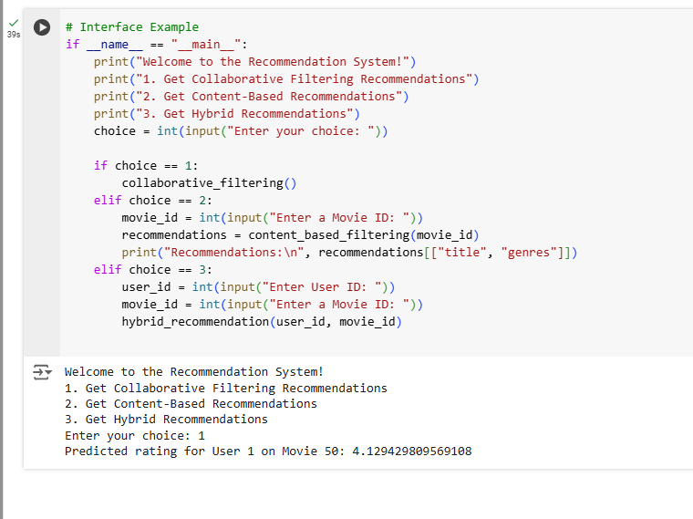

Acting as a prototype for further development, this interface displayed the fundamental capability of the system. One fascinating field of study is the development of HCI in recommendation systems. Growingly proactive, intelligent systems predict user wants and provide suggestions free from explicit input. Virtual assistants like Alexa and Siri, for instance, utilize contextual data—user location and time of day—to provide ideas ahead of time. Natural language processing (NLP) and voice recognition advances are increasing conversational ability of these devices thus allowing users to communicate with them more organically. Recommendation systems should becoming increasingly more ingrained into our everyday life as artificial intelligence technologies develop, offering flawless and tailored experiences.

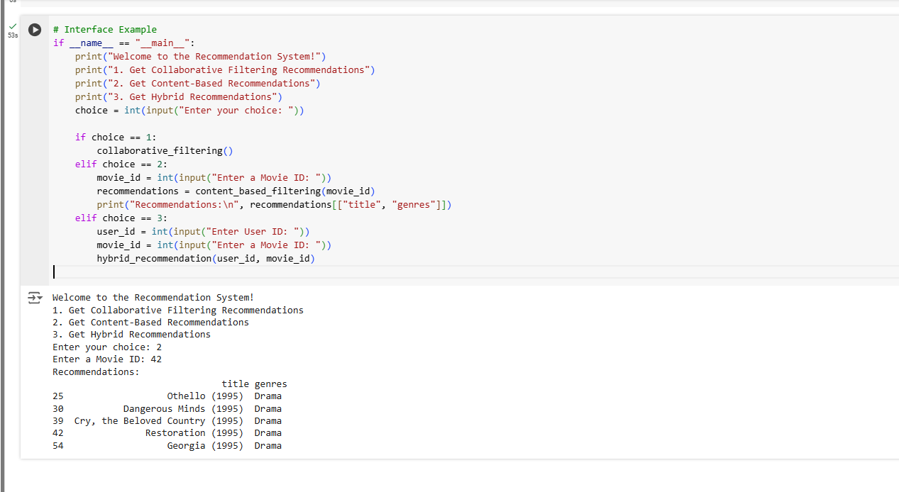

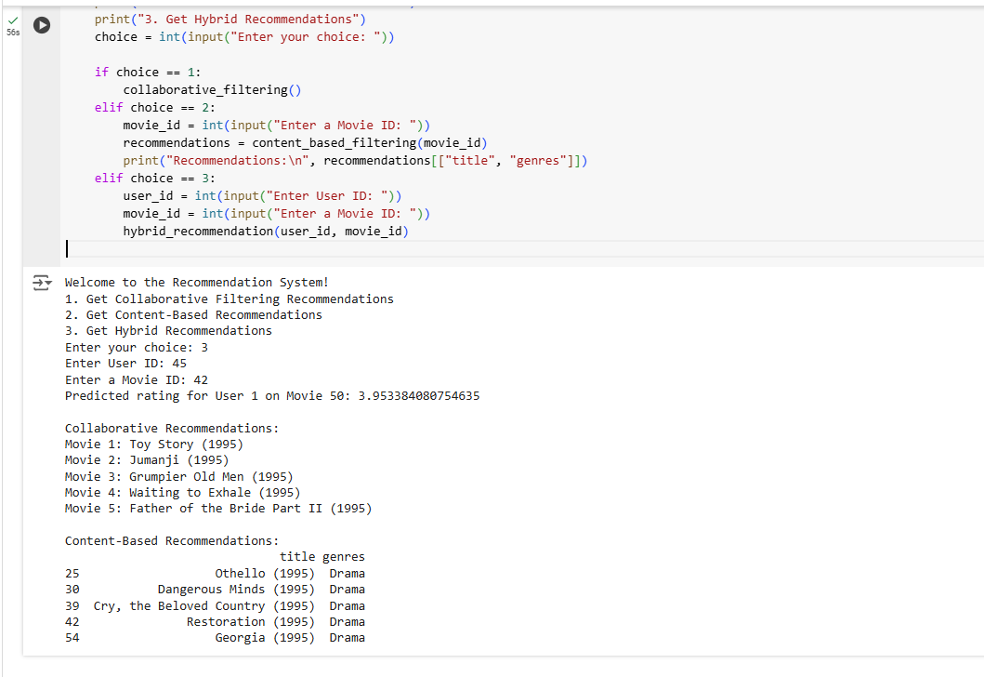

# Future Improvements and Challenges

Though our recommendation system showed encouraging performance, various things might be done. First, using deep learning methods such recurrent neural networks and neural collaborative filtering could improve the capacity of the system to replicate intricate user-item interactions (He et al., 2017). Large-scale datasets have demonstrated these approaches to beat conventional matrix factorization algorithms. Second, solving the cold-start issue is still somewhat difficult. Lack of previous data causes collaborative filtering techniques to find inaccurate suggestions for new users or goods. Using hybrid techniques that combine demographic or contextual data might help to fill in the gaps. Demographic-based filtering may, for example, deduce preferences for new users from user characteristics including age, gender, and geography. Third, practical applications depend critically on scalability. Collaborative filtering and content-based filtering approaches expand exponentially in computational complexity as user and item counts rise. Methods include networked computing and approximative closest neighbor algorithms enable these systems to effectively manage large volumes. Recommendation system design calls for ethical issues to be finally addressed. These technologies might affect user behavior, which begs privacy, fairness, and bias questions. Maintaining user happiness and developing confidence depend on the system offering objective suggestions and safeguarding of user data.

# Conclusion

Powerful tools using artificial intelligence and human-computer interaction are recommendation systems, which improve user experience in many spheres. This paper described hybrid methods, content-based filtering, and collaborative filtering-based recommendation system development. Content-based filtering examined item properties using TF-IDF vectorization and cosine similarity; collaborative filtering modeled user-item interactions using the SVD method. Combining the qualities of both methods produced a more precise and strong answer from the hybrid system. Emphasizing the need of user involvement and system confidence, the role of HCI in creating simple interfaces was underlined. The paper also covered the future development of intelligent systems, foretelling more proactive behavior and integration into our everyday existence. Even if issues such the cold-start dilemma, scalability, and ethical questions still exist, developments in artificial intelligence and human-computer interaction provide interesting answers. This experiment showed generally the ability of recommendation systems to change user interaction with intelligent systems, therefore opening the path for more individualized and seamless experiences. Improving the scalability, precision, and fairness of these systems will help future studies to guarantee they satisfy the various demands of users.

# References

Burke, R. (2002). Hybrid recommender systems: Survey and experiments. *User Modeling and User-Adapted Interaction*, *12*(4), 331–370.

He, X., Liao, L., Zhang, H., Nie, L., Hu, X., & Chua, T. S. (2017). Neural collaborative filtering. In *Proceedings of the 26th International Conference on World Wide Web* (pp. 173–182).

Koren, Y., Bell, R., & Volinsky, C. (2009). Matrix factorization techniques for recommender systems. *Computer*, *42*(8), 30–37.

Lops, P., Gemmis, M. D., & Semeraro, G. (2011). Content-based recommender systems: State of the art and trends. In *Recommender Systems Handbook* (pp. 73–105). Springer.

Manning, C. D., Raghavan, P., & Schütze, H. (2008). *Introduction to information retrieval*. Cambridge University Press.